**Artificial Intelligence Project**

**Documentation**

**Sample Run**

1. **?- run**. To start Expert System

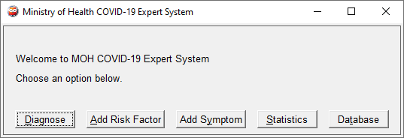

1. **Add Risk Factor** – Use to add increase_risk(X,covid)

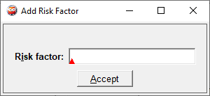

1. **Add Symptom** – Use to add symptom_of(X,covid)

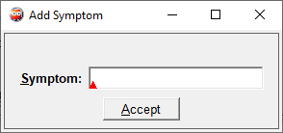

1. **Diagnose**

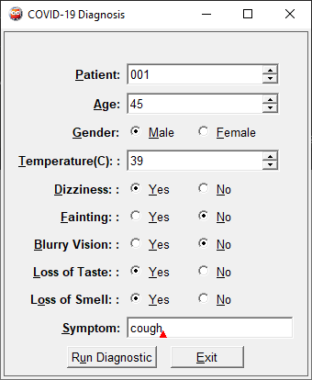

Run Diagnostic

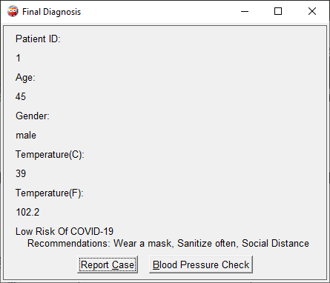

Blood Pressure Check

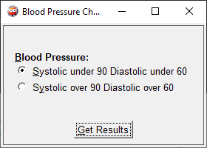

1. **Statistics**

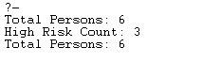

1. **Database**

